This Employee Non-Disclosure and Confidentiality Agreement (this “Agreement”) is entered into as of the 22nd May 2023 by and between Zediant Technologies, (the “Company”), and Rajesh Jaiswal (ZT0003, presently residing at J-470/F Paharpur Road, Garden Reach, Kolkata-700024), an employee of the Company (the “Employee”). The above parties may be referred to singularly as a “Party” or collectively as the “Parties”.
The Company hired Employee pursuant to the terms and conditions of that certain Letter of Appointment executed between the Parties on the 22nd May 2023. In connection with the Employee’s duties under the Letter of Appointment, the Company may disclose to the Employee certain confidential and proprietary information unique and valuable to its ongoing business operations. In consideration of the Employee’s employment by the Company and the covenants and mutual promises contained herein, the Parties agree as follows:
1. Confidential Information. The term “Confidential Information” as used in this Agreement shall mean any data, information, or knowledge disclosed by the Company to the Employee and not generally known to the public, including but not limited to:
- The Company’s list of existing clients and prospective client list and contact details of the persons working for such organizations;
- The Company’s business or operational plans or activities, existing or contemplated markets, advertising initiatives, methods of operation, products, or services;
- The Company’s suppliers or associates data;
- The Company’s customer or supplier lists, cost of services, profits and losses, budgeting, past or future sales, or financial information;
- The Company’s schematics, designs, software source or object code, compressed or uncompressed binaries, inventions, patents or patent applications or illustrations;
- The Company’s existing or contemplated designs, models or platforms, formulas, research, notes, or analytical data;
- The Company’s management, board of directors, affiliates, suppliers, customers, employees, or third-party contractors;
- The Company’s history, entity structure, accounts, or goodwill; the Company’s copyrights, trademarks, trade secrets, patents, trade names, moral rights, or any other tangible or intangible rights, whether registered or unregistered;
- The Company’s technical systems, processes, methods, algorithms, computational schemas, know-how, or trade secrets;
- The Company’s employees, salaries, job related functions, duties or responsibilities; the Company’s written, auditory or electronic communications;
- Any information that if disclosed, whether true or untrue, could harm the goodwill or reputation of the Company or the Company’s management, board of directors, affiliates, suppliers, customers, employees, third-party contractors, methods of operation, products, or services; or
- Any other information of any of whatever kind and nature that the Company desires to maintain confidential.
2. Exclusions to Confidential Information. The obligation of confidentiality with respect to Confidential Information will not apply to any information:
- If the information is or becomes publicly known and available other than as a result of prior unauthorized disclosure by the Employee;
- If the information is or was received by the Employee from a third-party source which, to the best knowledge of the Employee, is or was not under a confidentiality obligation to the Company with regard to such information;
- If the information is disclosed by the Employee with the Company’s prior written permission and approval;
- If the information is independently developed by the Employee prior to disclosure by the Company and without the use and benefit of any of the Company’s resources; or
- If the Employee is legally compelled by applicable law, by any court, governmental agency, or regulatory authority or subpoena or discovery request in pending litigation, but only if, to the extent lawful, the Employee gives prompt written notice of that fact to the Company prior to disclosure so that the Company may request a protective order or other remedy, the Employee may disclose only such portion of the Confidential Information which it is legally obligated to disclose.
3. Obligation to Maintain Confidentiality. With respect to Confidential Information:
- The Employee agrees to retain the Confidential Information in strict confidence, to protect the security, integrity, and confidentiality of such information and to not permit unauthorized access to or unauthorized use, disclosure, publication, or dissemination of Confidential Information except in conformity with this Agreement.
- Confidential Information is and will remain the sole and exclusive property of the Company and will not be disclosed or revealed by the Employee, except (i) to other employees of the Company who have a need to know such information and agree to be bound by the terms of this Agreement or (ii) with the Company’s express prior written consent.
- The Employee agrees that, in the event the Employee must download, access, process, transfer or otherwise communicate Confidential Information, the Employee will comply with all laws and regulations applicable to exports and re-exports of data and information and will not, directly or indirectly, export or re-export any Confidential Information in violation of such laws and regulations, including without limitation, those prohibiting export or re-export to restricted countries or without governmental authorization.
- Upon termination of this Agreement or at the request of the Company, the Employee will ensure that all Confidential Information and all documents, memoranda, notes and other writings or electronic records prepared by the Employee that include or reflect any Confidential Information in the Employee’s actual or constructive possession are returned to the Company within one business day.
- The obligation not to disclose Confidential Information shall survive the termination of this Agreement, and at no time will the Employee be permitted to disclose Confidential Information, except to the extent that such Confidential Information is excluded from the obligations of confidentiality under this Agreement pursuant to Paragraph 2 above.
4. Disclaimer. There is no representation or warranty, express or implied, made by the Company as to the accuracy or completeness of any of its Confidential Information.
5. Remedies. The Employee acknowledges that use or disclosure of any confidential and proprietary information in a manner inconsistent with this Agreement will give rise to irreparable injury for which only bearing financial damages would not be an adequate remedy. Accordingly, in addition to any other legal remedies which may be available at law or in equity, the Company shall be entitled to equitable or injunctive relief against the unauthorized use or disclosure of confidential and proprietary information. The Company shall be entitled to pursue any other legally permissible remedy (including pressing criminal charges against the employee) available as a result of such breach, including but not limited to damages, both direct and consequential. In any action brought by the Company under this Section, the Company shall be entitled to recover its attorney’s fees and costs from Employee.

6. Termination. This Agreement will terminate on the written agreement of the Parties to terminate this Agreement.
7. Amendment. This Agreement may be amended or modified only by a written agreement signed by both of the Parties.
8. Entire Agreement. This Agreement constitutes the entire agreement between the Parties and supersedes all prior or contemporaneous negotiations, discussions or agreements, whether written or oral, regarding the subject matter hereof.
10. Miscellaneous. In the event that any provision of this Agreement is held to be invalid, illegal or unenforceable in whole or in part, the remaining provisions shall not be affected and shall continue to be valid, legal and enforceable as though the invalid, illegal or unenforceable parts had not been included in this Agreement. Neither Party will be charged with any waiver of any provision of this Agreement, unless such waiver is evidenced by a writing signed by the Party and any such waiver will be limited to the terms of such writing.
By your signature below you acknowledge that you have read and understand the foregoing Agreement, that you agree to comply with all of the terms of the Agreement, and that you have received a copy of the Agreement.

For Employee  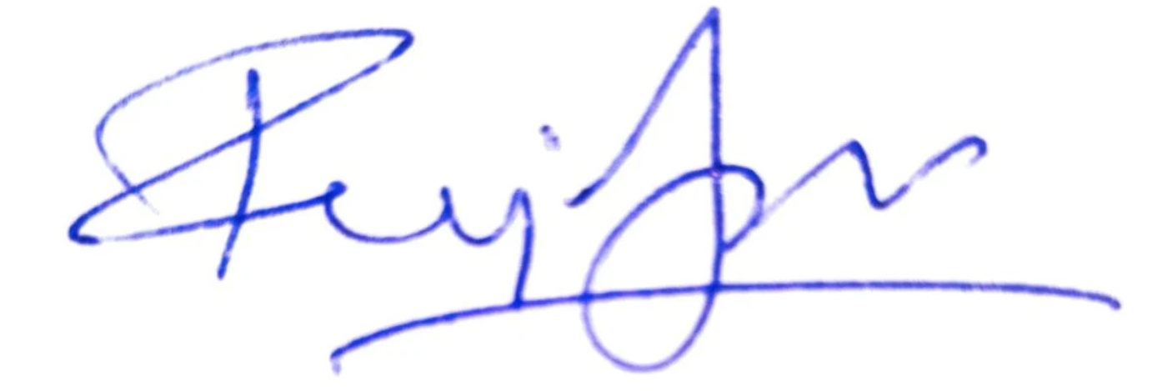  Signature:  Name: Rajesh Jaiswal  Date: 22nd May 2023 | For Zediant Technologies  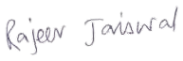  Signature:  Name: Rajeev Jaiswal  Designation: Director  Date: 22nd May 2023

